21BDS0340

Abhinav Dinesh Srivatsa

Chemistry Lab

# FAT Exam

**Question Paper – Data Set 10**

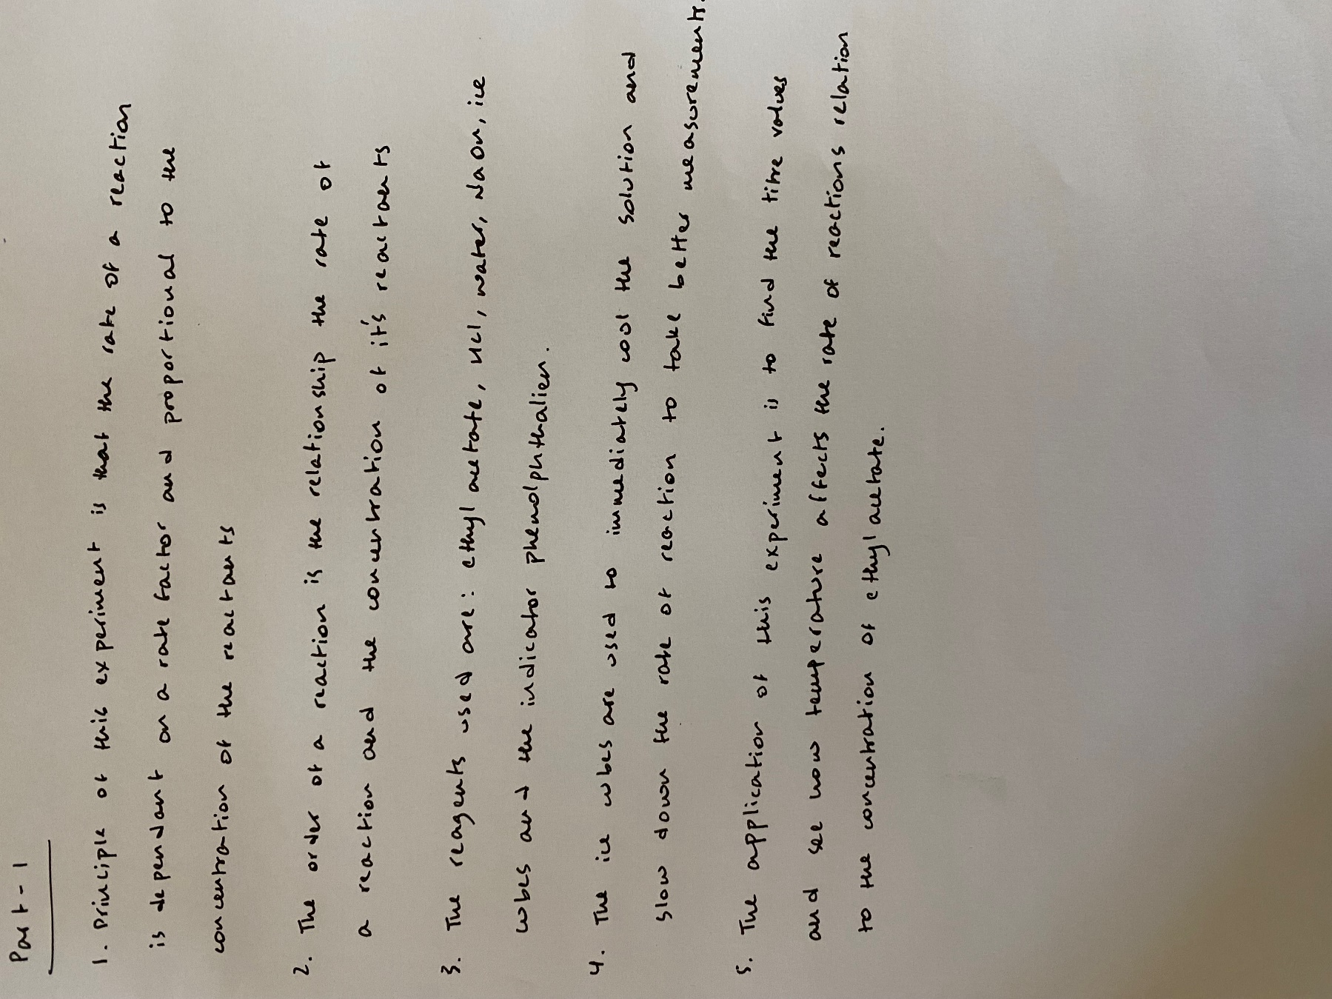**Part I**

**Part II**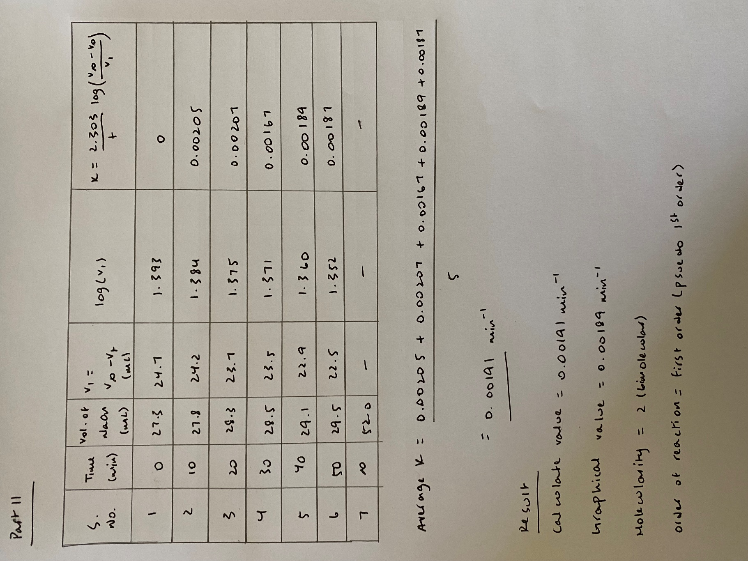

**Graph**

